Week-2

Ranking and Window Functions

1) ROW_NUMBER()

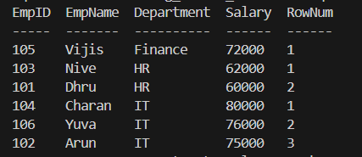

2) RANK()



3) DENSE_RANK()



